DSC530: Data Exploration and Analysis

Week 3

Astrid Fuentes

Think Stats

Exercise 2-1.

Page 25

**Based on the results in this chapter, suppose you were asked to summarize what you learned about whether first babies arrive late.**

Based on what we learned in this chapter, I do not think we conclude that first babies arrive late.

**Which summary statistics would you use if you wanted to get a story on the evening news?**

If I wanted to get a store on the evening news, I would probably base my story on the histogram of pregnancy lengths and make emphasis in the fact that the majority of the babies born after week 40 are first babies. In fact, to make it even more dramatic, I would adjust the axis on the figure below to show only data after the week 40.

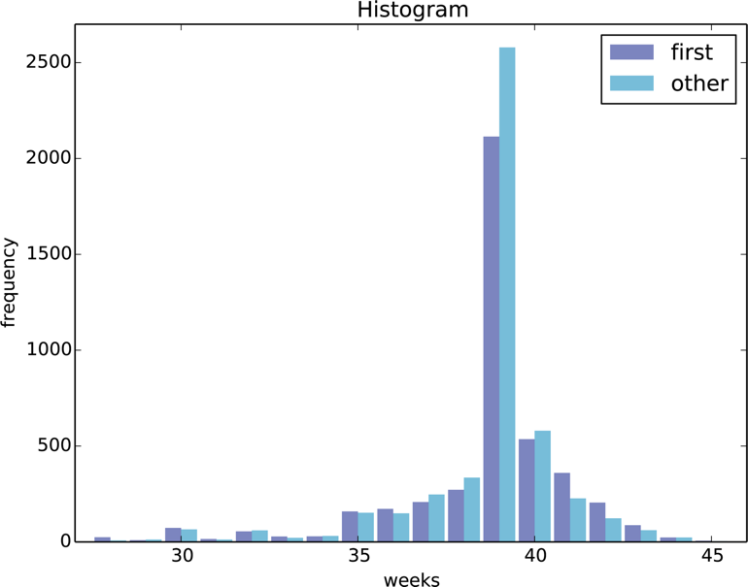page39image57924544

**Which ones would you use if you wanted to reassure an anxious patient?**

To reassure and anxious patient I would also show them the histogram and explain how there is a number of babies born late regardless of being first baby or other.

I would also explain the mean and variance: For all live births, the mean pregnancy length is about 38.601 weeks with a standard deviation of 2-3 weeks, while the mean pregnancy length for first babies is 38.601and for all other babies it is 38.523. This only represents a difference of 13 hours or 0.2%.

**Finally, imagine that you are Cecil Adams, author of The Straight Dope, and your job is to answer the question, “Do first babies arrive late?” Write a paragraph that uses the results in this chapter to answer the question clearly, precisely, and honestly.**

Based on data collected from the National Survey of Family Growth (NSFG), the most common pregnancy length is 39 weeks. Also, early babies are common and late babies usually do not go beyond week 43 because doctors intervene to induce birth. The sample data has about 9 thousand live births of woman, the first babies were identified, and statistical measures were calculated to conclude that: For all live births, the mean pregnancy length is about 38.601 weeks with a standard deviation of 2-3 weeks, while the mean pregnancy length for first babies is 38.601and for all other babies it is 38.523. This only represents a difference of 13 hours or 0.2%. The difference in means was also calculated using a measure called Cohen’s d to conclude that the difference in means is 0.029 standard deviations which is too small to be considered significant. This also indicates that there is no significant difference between the pregnancy length of first-born babies and the pregnancy length of the other babies. Based on this evidence, we can say that first babies not always arrive late. However, there could be medical conditions for individual mothers that could cause their babies to arrive late regardless of them being first baby or not.